Type-C Female to Lightning Male Charge & Sync Conversion Adapter

Charge and Sync your Lightning connected

iPhoneTM, iPadTM and iPodTM using existing Type-C cables
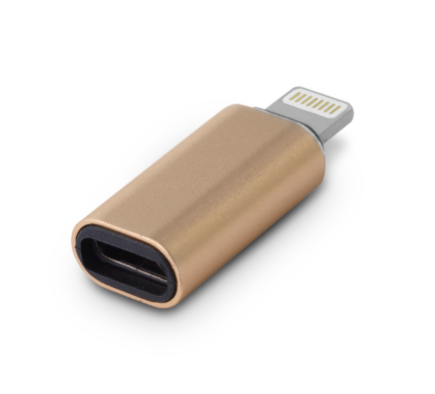

Descrption:
Need to charge or data sync your iPhoneTM, iPadTM or other connected Lightning interfaced AppleTM device but don't have a Lighting cable?

Simply plug our adapter into your device's Lightning port and connect your existing Type-C cable for not only charging your AppleTM device but also syncing any data, such as for iTunesTM.

Compact and stylish with a durable aluminum alloy construction that's totally Plug n' Play for your AppleTM digital devices.

SPECIFICATIONS
- Lighting to TYPE C Connector
- Connector: Lightning male/Type-C female
- material:aluminum alloy
- product size： 30x12x7mm

Product Code:
- Part number: C-TC-LIGHT
- Product net weight: 2g
- Barcode: 8400800036711

